**Fitness Unit Study Guide**

**Purpose:**

Weight training, strength training and resistance training are all methods adapted to improve the resistance and size of the skeletal muscles. Weight training involves the application of a variety of equipment to target specific muscle groups and types of movement, such as weighted bars, dumbbells, Kettlebells, and weight stacks. Though weight training differs from bodybuilding and

weightlifting, it forms a vital component of any well rounded fitness routine. Weight training is

not just for athletes but also for all types of people, since it offers a continuum of benefits such as increased muscle strength, enhanced muscle tone, better flexibility, as well as balance, prevention of muscle and joint injury and decreased risk of cardiovascular (heart) disease and stroke. Above all, weight training has been proven to be effective in building endurance, thereby enabling your body to work harder.

**Guidelines:**

*Warm up muscles for a minimum of 3-5 minutes prior to exercising

*Start with a light jog, jumping jacks or some other form of cardio exercise to get the blood flowing and to increase heart rate

*Follow with some ballistic and static stretches to get the muscles ready for weight training

*Perform 12-15 repetitions of each exercise and adhere to specific exercise techniques

*Perform 2-3 sets of each exercise taking a short break in between each set

*Perform exercises in a controlled manner and maintain a normal breathing pattern

*Cool down once finished weight training 3-5 minutes of ballistic and static stretches

**Safety:**

*Always do some form of warm up and cool down each time you train

*Do not attempt to lift more than you are capable

*Start with lighter weights when learning proper exercise techniques

*Keep adequate distance between lifter and the equipment

*Only increase weight once 12-15 repetitions become easy (progression)

*Avoid dropping weights on the floor

*Report any injuries to the instructor immediately

*Absolutely no horseplay before, during or after weight training session

**Vocabulary:**

Ballistic Stretching – as series of quick but gentle bouncing or bobbing motions designed to

stretch muscles.

Static Stretching – stretching slowly as far as possible without pain, breathing evenly throughout the stretch.

Circuit Training – a type of physical activity program in which the person performs a group of

exercises in a sequence with a brief rest between exercises.

Interval Training – physical activity in which short bursts of high-intensity exercise are

alternated with rest periods that are predetermined to create a specified result.

Warm up – a series of activities, usually consisting of a heart warm-up, a muscle warm-up and

stretch, to prepare the body for more vigorous exercise and help prevent injury.

Cool down - a series of activities, usually consisting of a light stretch, walk, and/or yoga with the purpose of allowing the muscles and heart to return to resting in a smooth and comfortable way.

*Health Related Fitness*

Cardiovascular endurance: the ability to exercise your entire body for long periods of time without stopping (30 min or more). (eg. Long distance running, swimming, or hiking)

Muscular Strength: the amount of force your muscles can produce. This is measured by how much you can lift or how much resistance you can overcome. (eg. Weight lifiting, strong man competition, or football)

Muscular endurance: the ability to use your muscles many times without tiring. (eg. Soccer, water polo, or crossfit)

Flexibility: the ability to use your joints fully through a wide range of motion

Body composition: the percentage of body weight that is made up of fat when compared to the

other tissues, such as bone and muscle. (eg. Gymnastics, yoga, or wrestliling.)

*Skill Related Fitness*

Agility: the ability to change the position of your body quickly and to control your body’s movements

Balance: the ability to keep an upright posture while standing still or moving

Coordination: the ability to use your senses together with your body parts or to use two or

more body parts together

Power: the ability to use strength quickly. Involves both strength and speed

Reaction time: the amount of time it takes to move once you realize the need to act

Speed: the ability to perform a movement or cover a distance in a short period of time FITT Principle

Frequency: how many days per week you exercise

Intensity: how hard or much energy you put out during exercise

Time: how long you exercise continuously

Type: specificity, refers to the specific physical activity chosen to improve a component of health related fitness.

**F.I.T.T. ACTIVITY CHART**

|  |  |  |
| --- | --- | --- |
|  | BEGINNER ZONE FOR EXERCISE | MODERATE TO ADVANCED |
| Frequency | 3 days / week | 3 – 6 days / week |
| Intensity | 50%-60% MaxHR | 60 – 85% MaxHR |
| Time | 20 continuous minutes | 20 – 60 continuous minutes |

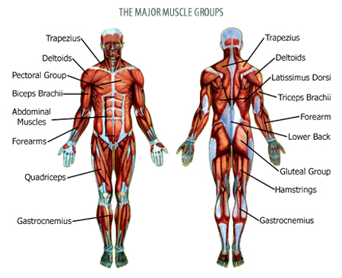

**Bones of the Body**

